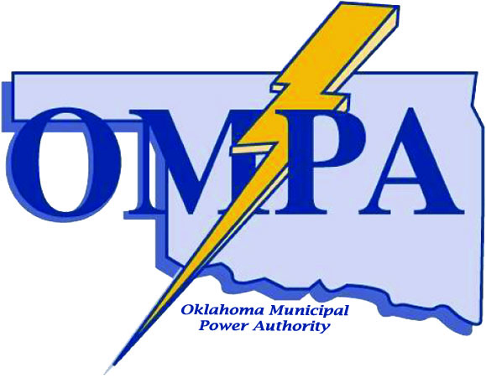
PRESS RELEASE

FOR IMMEDIATE RELEASE

FOR MORE INFORMATION: Contact Drake Rice, Director of Member Services, 405/359-2500

June 4, 2013 Charles D. Lamb Energy Center Update:
Activities in preparation for construction of the Charles D. Lamb Energy Center are progressing. A summary of recent events are:

- The OMPA Board of Directors has awarded the following contracts related to the project:
TIC - The Industrial Company was awarded the Switchyard EPC
Custom Instrumentation Services Corporation (CiSCO) was awarded the CEMS
ABB was awarded the Generator Step-Up Transformer
ABB was awarded the Generator Breaker
WEG was awarded the Unit Auxiliary Transformer
- OMPA and the City of Ponca City have reached an agreement for water supply to the facility
- OMPA and Southern Star have reached agreement for gas transportation services.
- On May 14, 2013 OMPA held a public meeting in Ponca City to discuss the project and received no negative comments or concerns.
- OMPA expects to be awarding more bids at its June meeting

